

|  |
| --- |
| Linux系统编译 v1.0 |
| 基于TI AM335x核心平台 |
|  |

免责声明

本文档是作者对GOEMBED 产品进行实际操作和测试后，自我操作总结。由于作者水平有限，建议读者具备一定的计算机基础和基本软件操作能力，如在操作过程中，遇到疑问和错误，欢迎加QQ群(462424566)交流和建议，或发厂商技术支持邮箱进行咨询: support@goembed.com

操作环境配套说明：

|  |  |
| --- | --- |
| 硬件 | 详细介绍链接 |
| SBC3358-B1A单板机 | [c:\users\administrator\appdata\roaming\360se6\User Data\temp\1411389502416719.jpg](http://www.goembed.com/index.php/Products/detail/tpid/25) |
| 串口调试器：COM10U | [c:\users\administrator\appdata\roaming\360se6\User Data\temp\1408786855283579.jpg](http://goembed.com/index.php/Products/detail/tpid/16) |

|  |  |
| --- | --- |
| 软件 | 详细介绍链接 |
| Ubuntu版本：12.04 LTS（64bit） | [http://www.ubuntu.org.cn/download/desktop](http://www.ubuntu.org.cn/download/desktop%20) |
| Linux版本：3.11.0-15-generic |
| gcc版本：4.6.3 |

### SBC3358-B1A单板机软件特性

#### 1、BootLoader版本：u-boot-2013.01.01

#### 2、内核版本：Linux-3.2.0

* LCD驱动
* LCD背光驱动
* 电阻式触摸屏驱动
* VGA驱动
* HSMMC/SD/MMC/SDIO驱动
* IIC驱动
* SPI驱动
* 音频驱动
* DMA驱动
* RTC实时时钟驱动
* 电源管理
* USB HOST/DEVICE驱动
* USB OTG驱动
* DEBUG驱动
* 以太网驱动
* TF卡驱动
* CAN驱动
* 串口驱动
* WG驱动

#### 3、交叉工具链：arm-Linux-gnueabihf-gcc

### SBC3358-B1A单板机资源分配特性

#### eMMC空间分配

|  |  |  |
| --- | --- | --- |
| Partition | Size | Description |
| BootLoader | **200MB** | **FAT32格式分区** |
| rootfs | **约1500MB** | **EXT3格式分区** |

### 一、安装交叉编译器

1、拷贝 i686-arago-Linux.tar.bz2 到 $HOME 下。

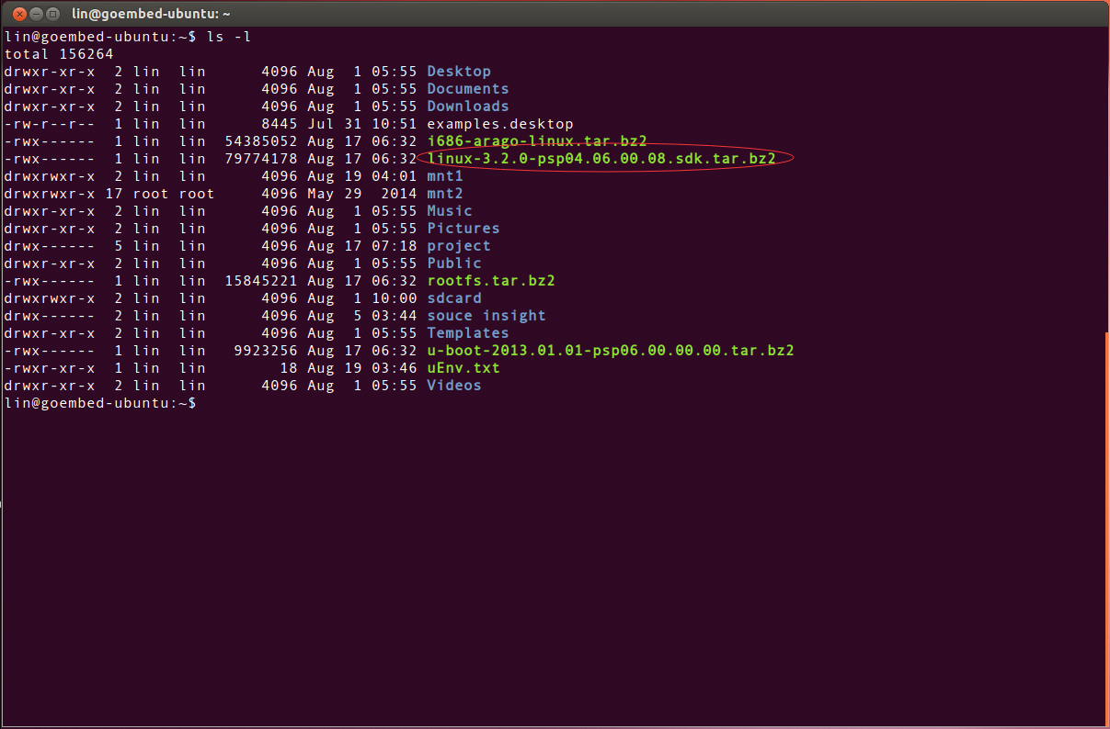

2、解压到当前目录：

* 命令：

tar -jxvf i686-arago-Linux.tar.bz2

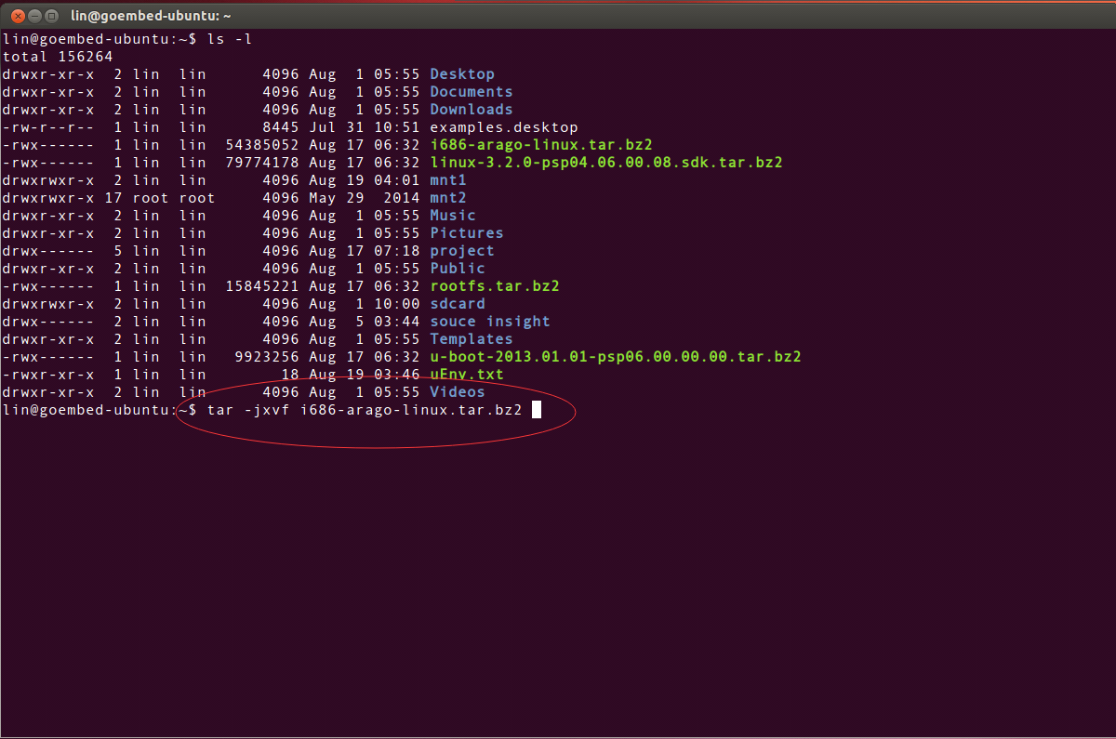

3、解压完成后的截图如下：

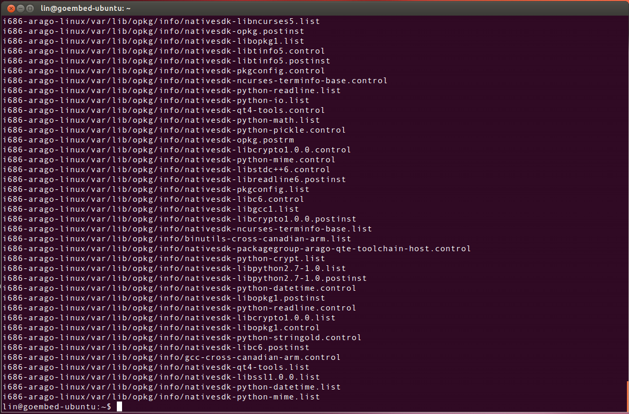

4、解压完成后导出编译器的环境变量

* 命令：

export PATH=$HOME/i686-arago-Linux/usr/bin/:$PATH

（如果要每次登陆都自动为该环境变量，则在/etc/profile文件中的最后一行添加该命令，然后重启系统）

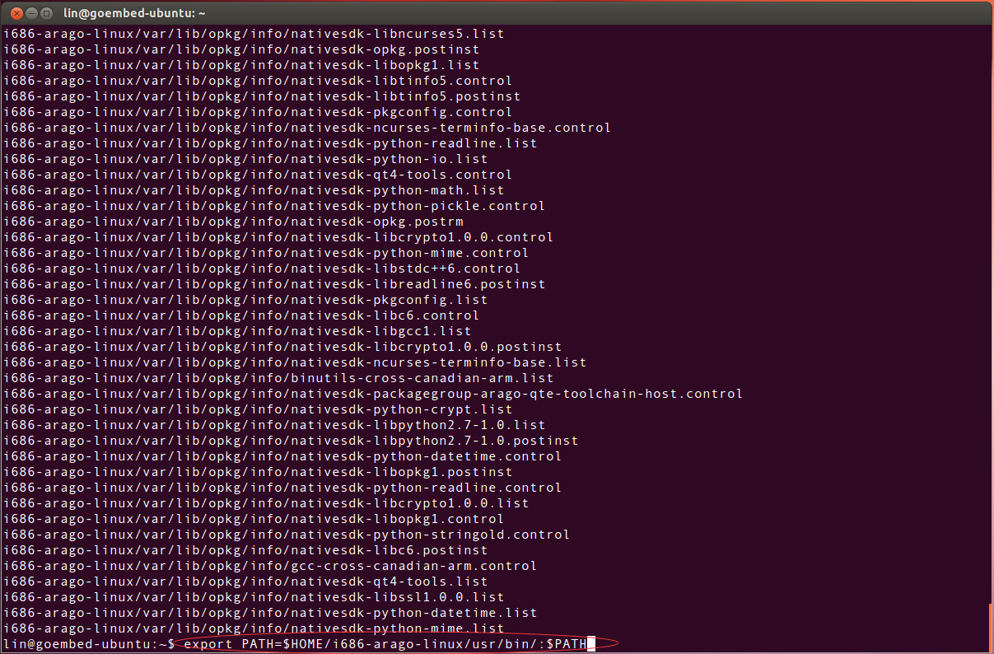

arm+TAB键可看到已成功导出

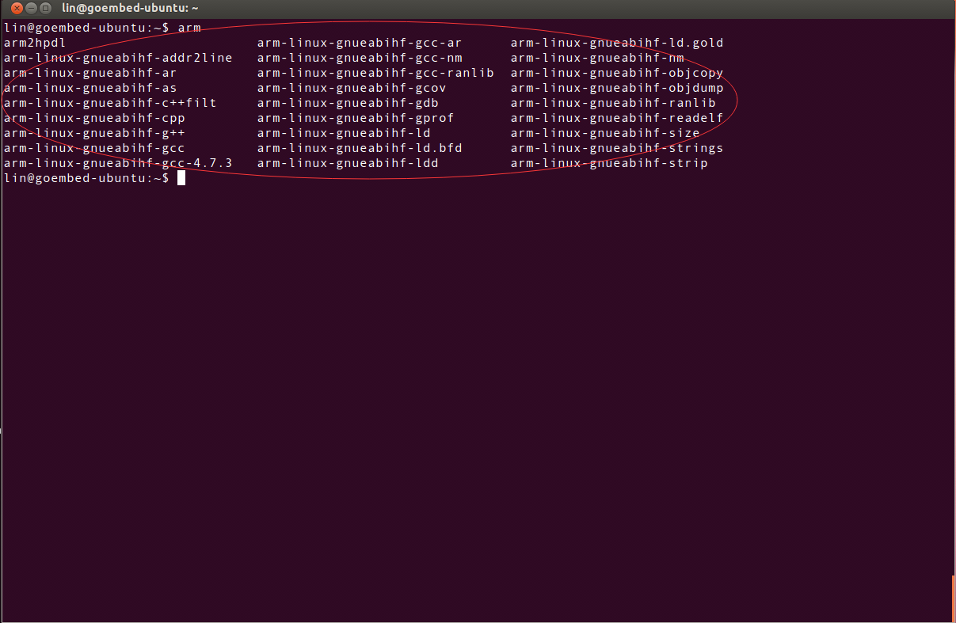

### 二、编译U-Boot

1、拷贝 u-boot-2013.01.01-psp06.00.00.00.tar.bz2 到 $HOME

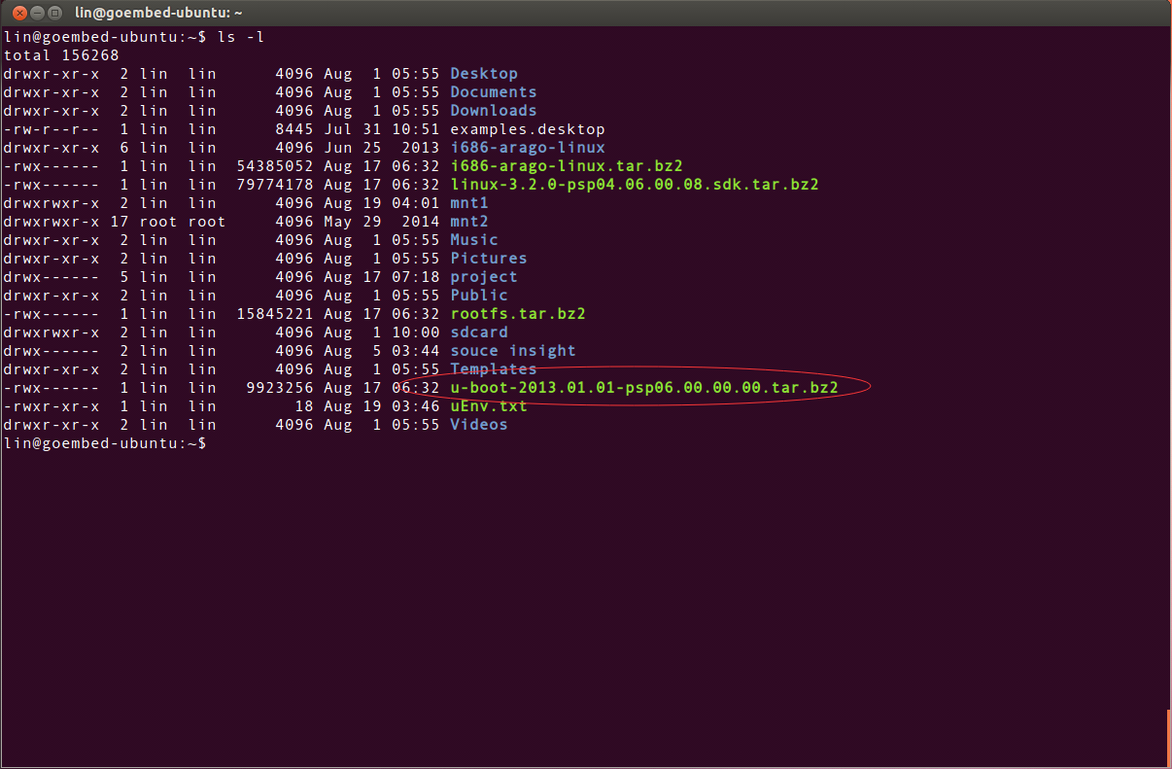

2、解压U-Boot源码包

* 命令：

tar -jxvf u-boot-2013.01.01-psp06.00.00.00.tar.bz2

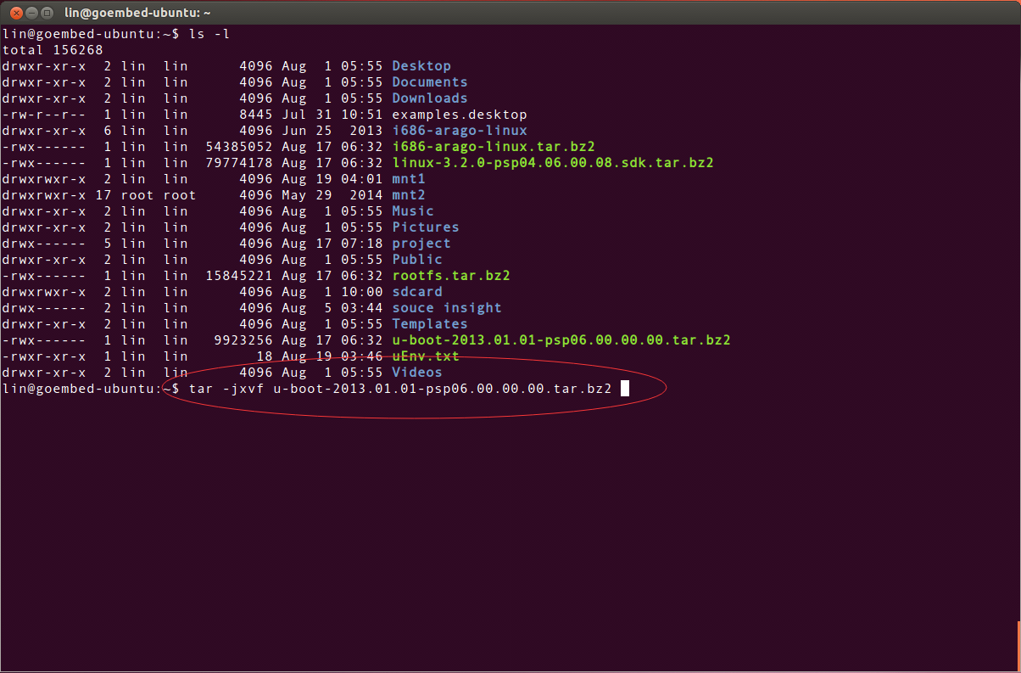

解压完成后：

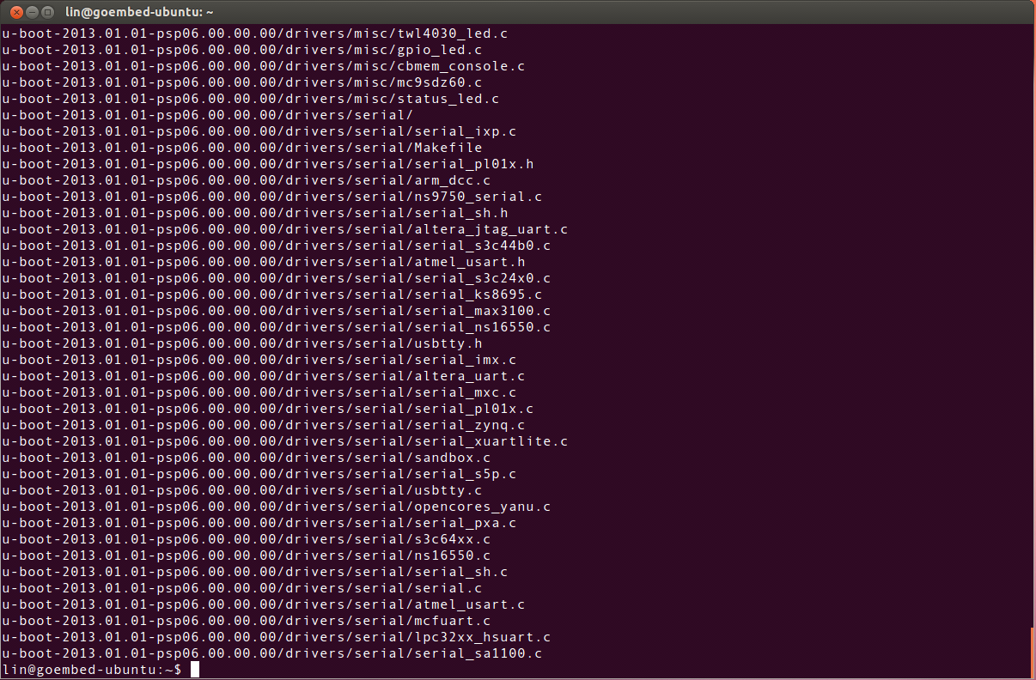

3、进入u-boot-2013.01.01-psp06.00.00.00目录

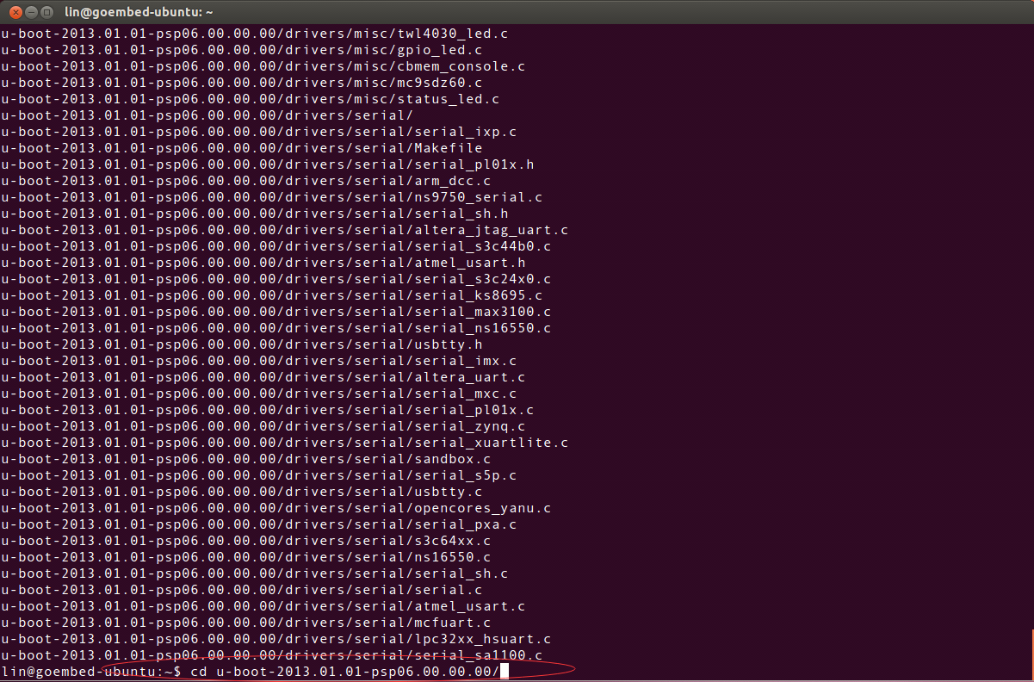

4、删除旧的am335x文件夹（如果有的话）

* 命令：

rm -rf am335x

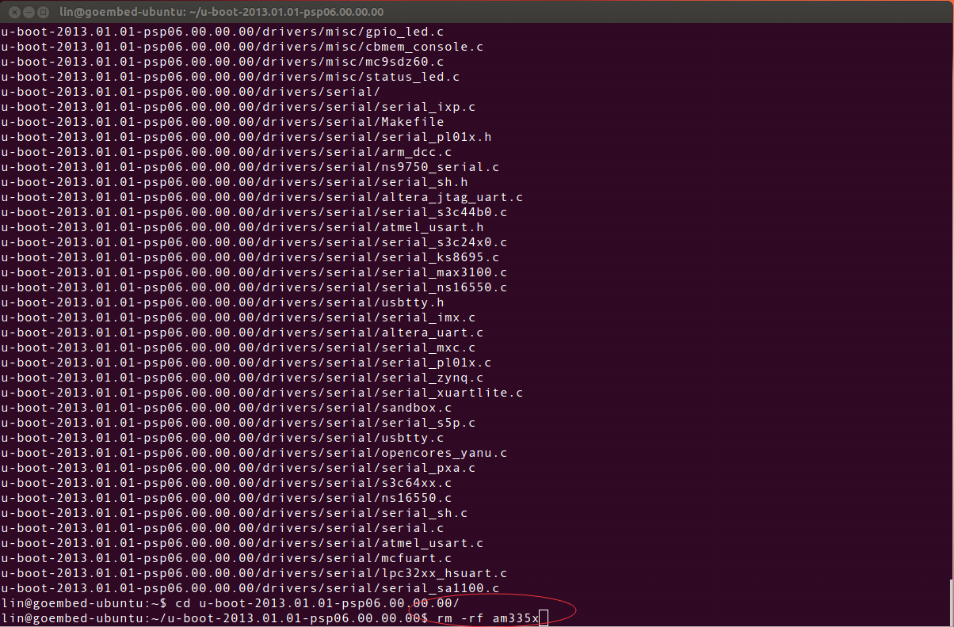

5、执行编译命令

* 命令：

make O=am335x CROSS_COMPILE=arm-Linux-gnueabihf- ARCH=arm am335x_evm

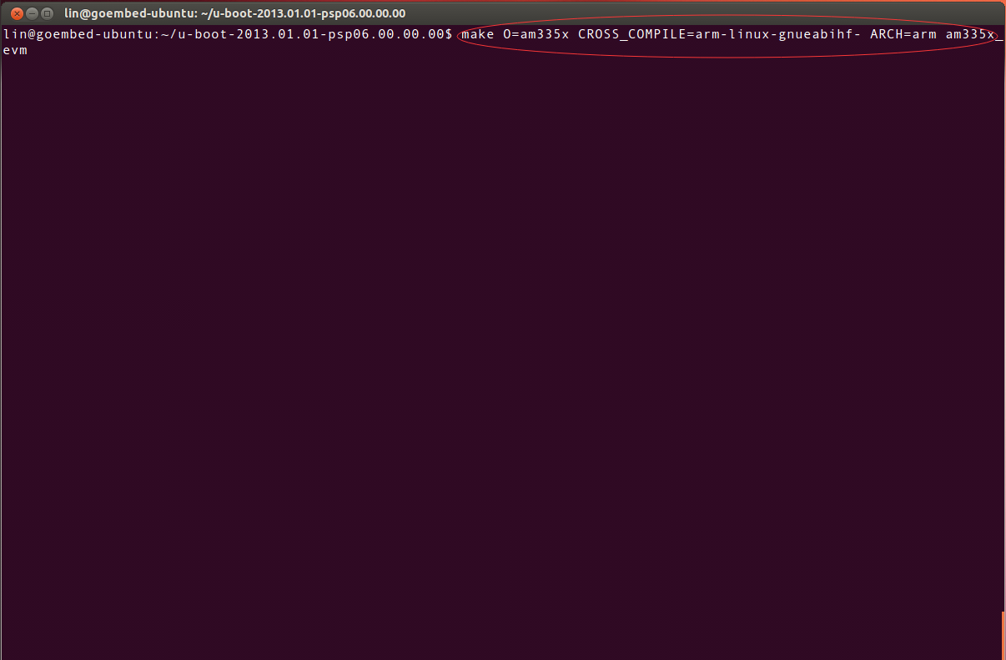

编译完成后出现新的am335x文件夹

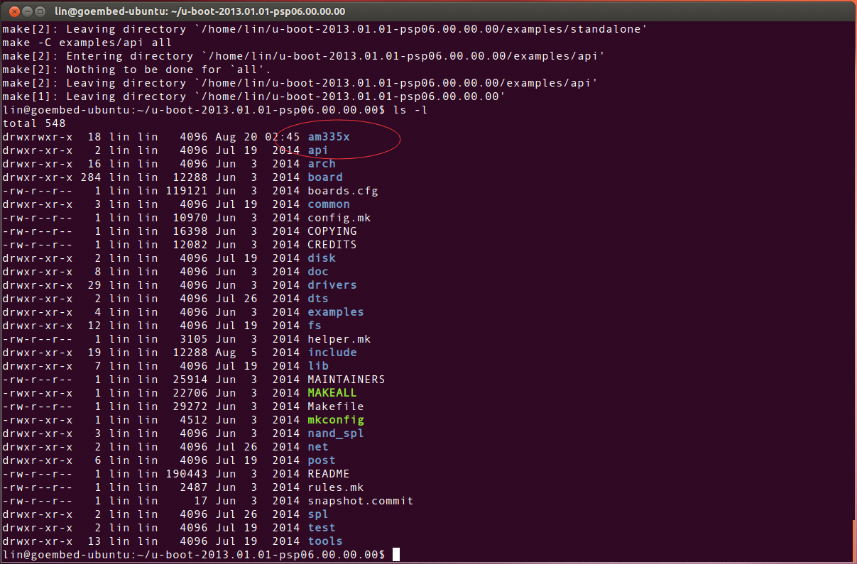

6、查看成功编译出来的u-boot.img和MLO

* 命令：

ls am335x -l

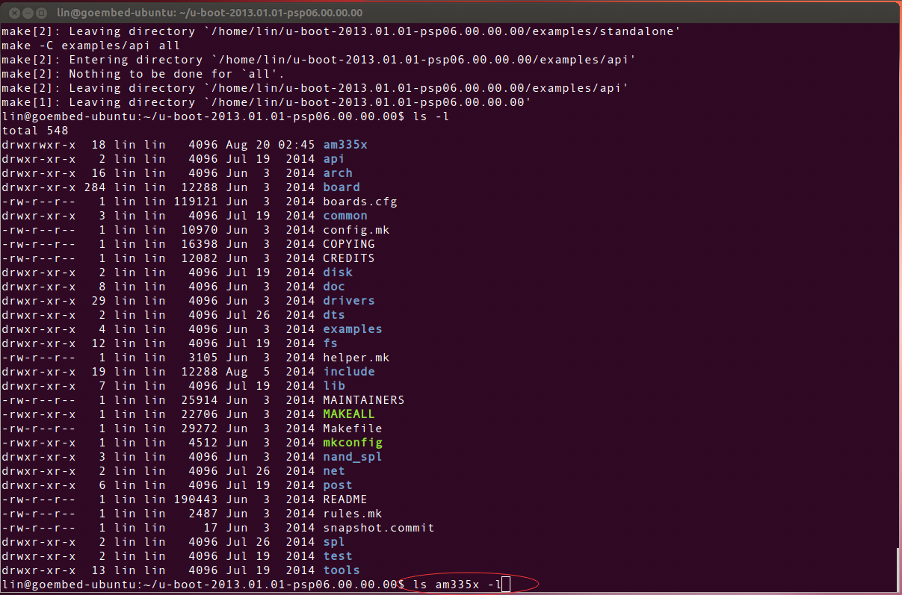

**查看结果：**

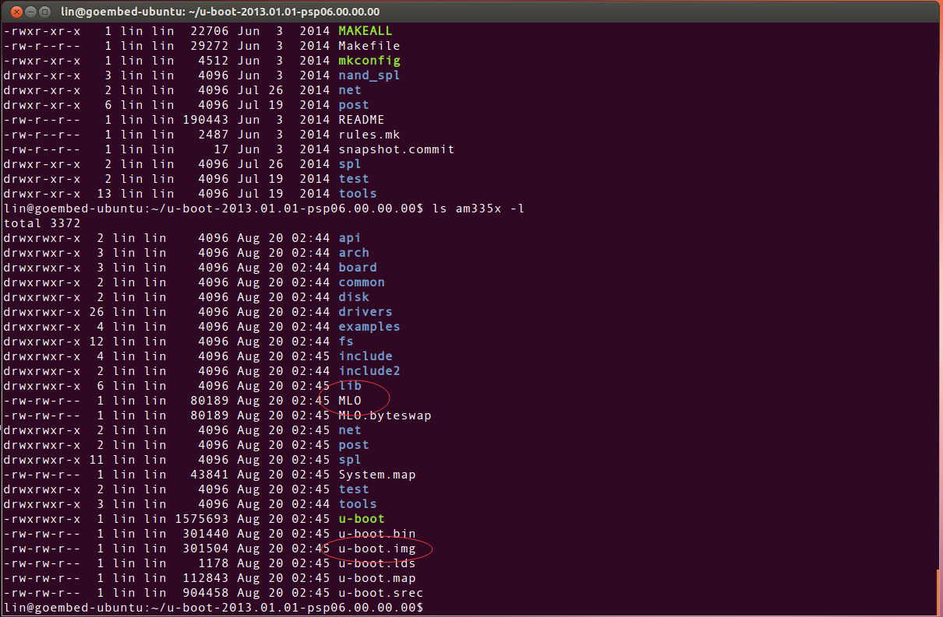

### 三、编译uImage

**1、拷贝 Linux-3.2.0-psp04.06.00.08.sdk.tar.bz2 到 $HOME**

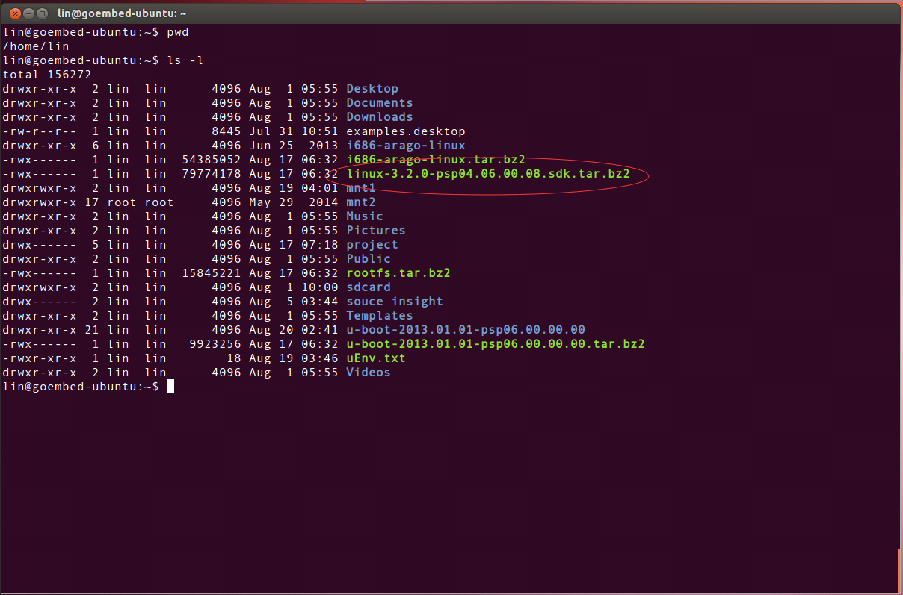

2、解压源码包

* 命令：

tar -jxvf Linux-3.2.0-psp04.06.00.08.sdk.tar.tar.bz2

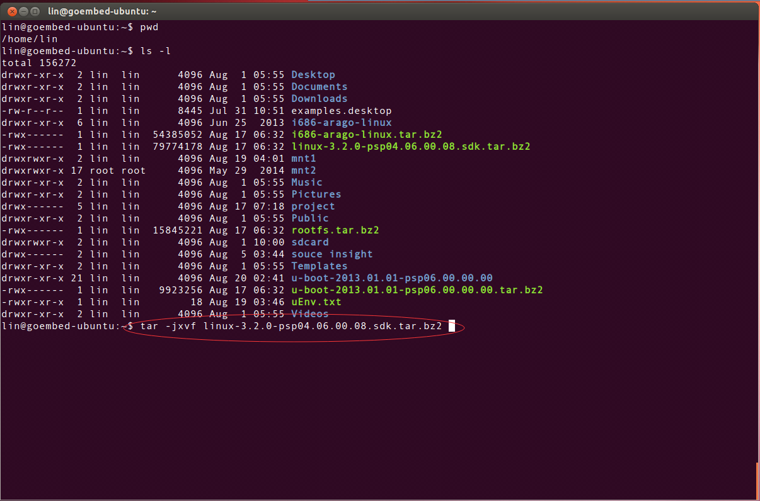

解压后：

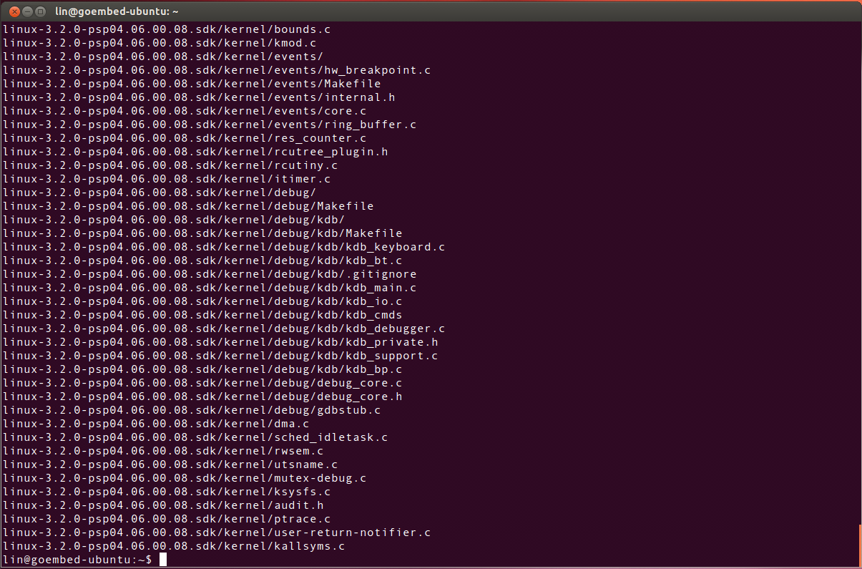

3、进入解压出来的目录Linux-3.2.0-psp04.06.00.08.sdk

* 命令：

cd Linux-3.2.0-psp04.06.00.08.sdk

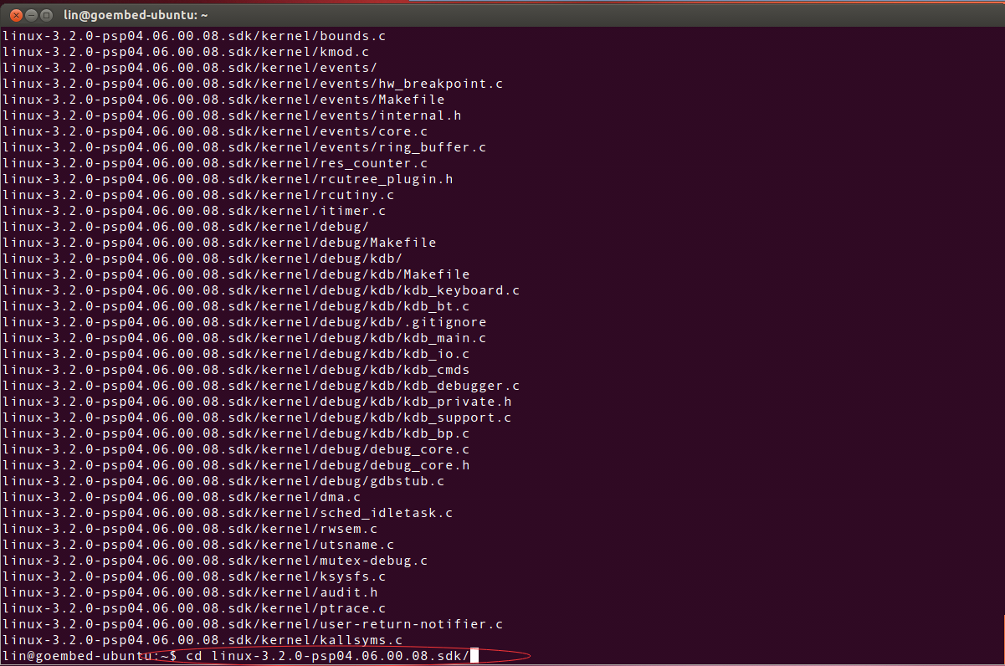

4、清理一下旧文件（没有旧文件会提示）

* 命令：

make O=am335x CROSS_COMPILE=arm-Linux-gnueabihf- ARCH=arm distclean

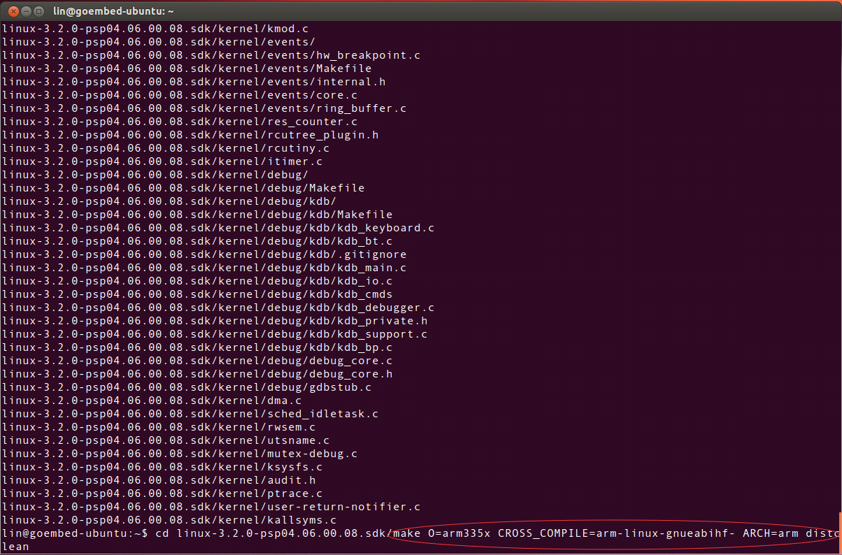

没有旧文件时提示：

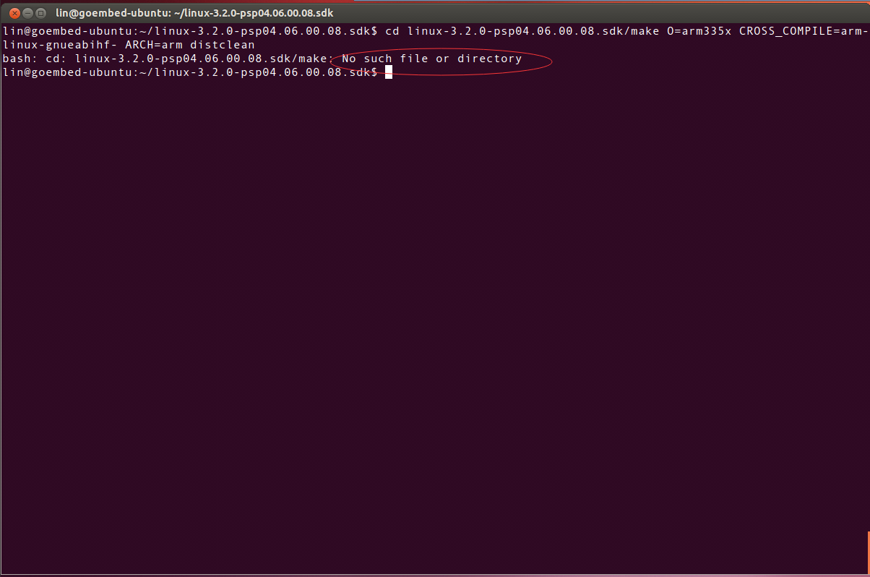

5、编译配置文件

* 命令：

make ARCH=arm CROSS_COMPILE=arm-Linux-gnueabihf- cm335x_tisdk_defconfig

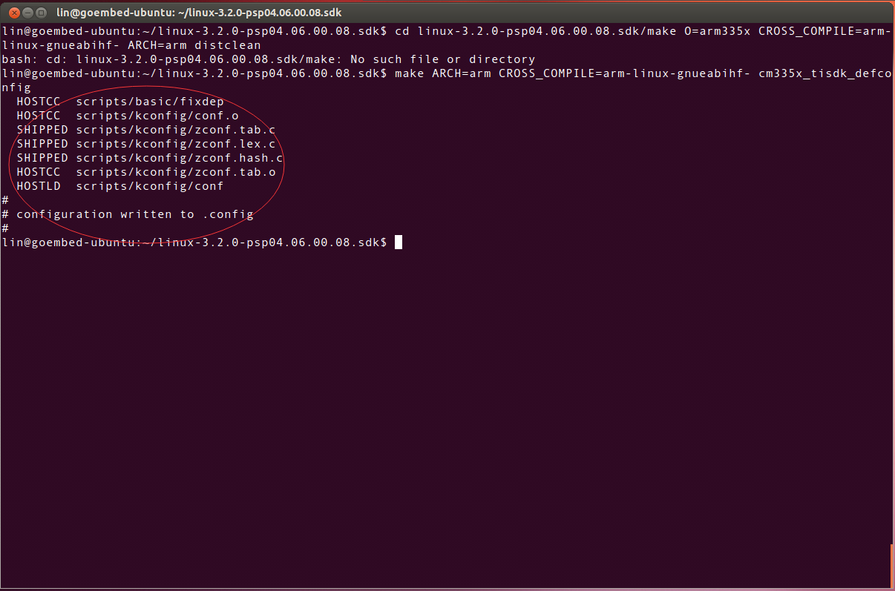

6、编译uImage

* 命令：

make ARCH=arm CROSS_COMPILE=arm-Linux-gnueabihf- uImage

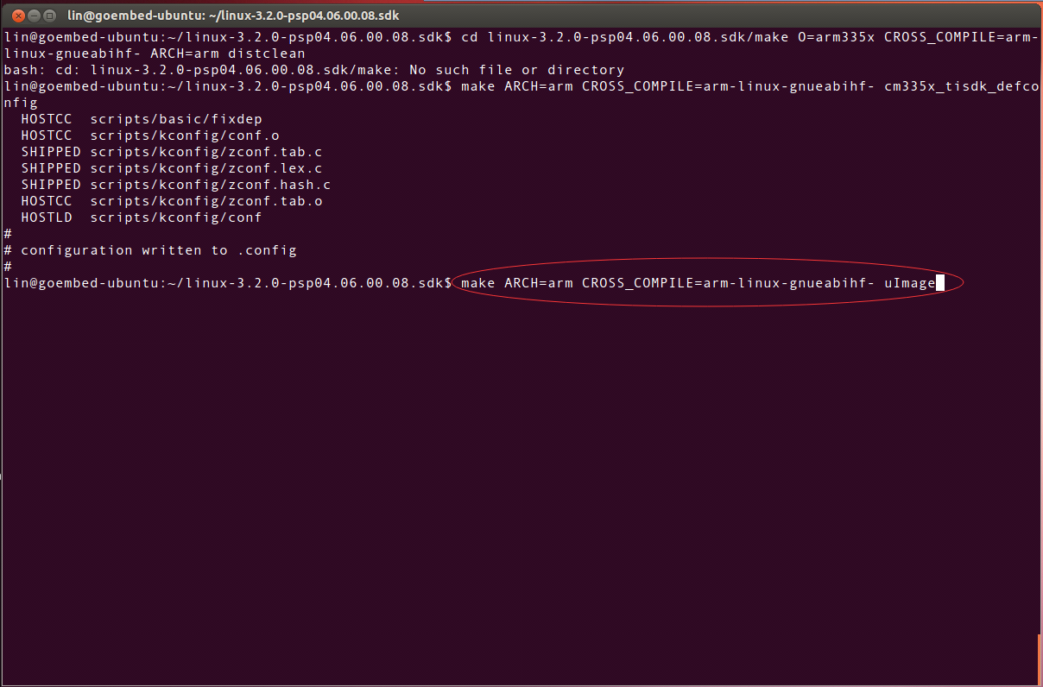

编译完成后提示：

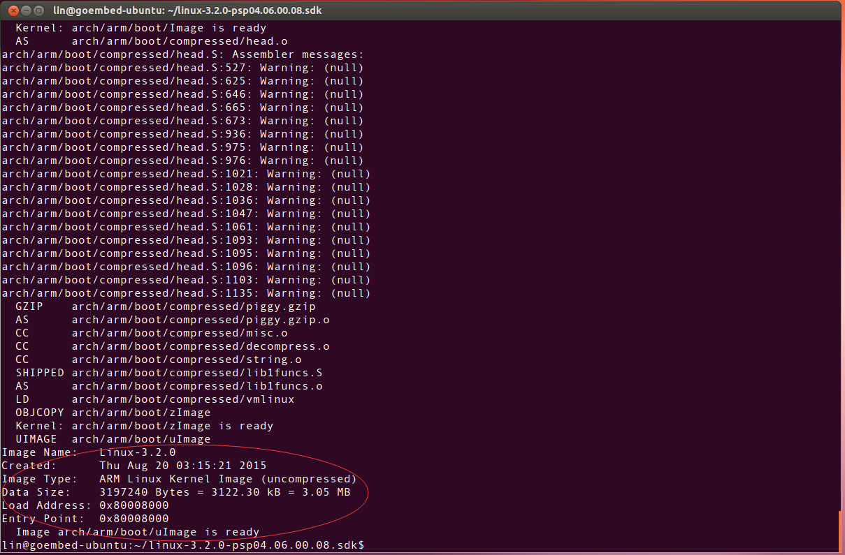

查看一下uImage有无生成：

* 命令：

ls arch/arm/boot/ -l

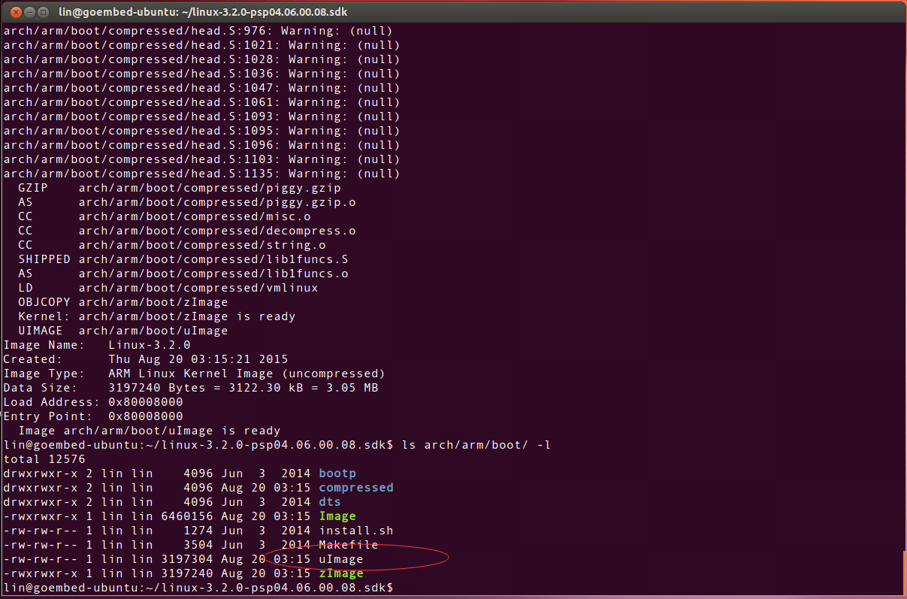

到此编译完成。

### 四、文件系统

资料中rootfs.tar.bz2 是一个精简的文件系统，到时直接解压就行。

到此，所有可执行文件准备完成。

附相关GOEMBED产品介绍

[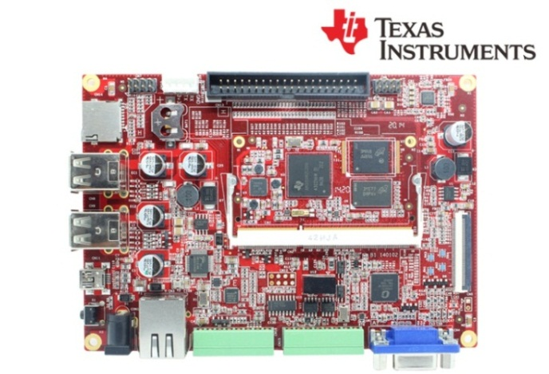](http://www.goembed.com/index.php/Products/detail/tpid/25)

*SBC335x – B1A*

[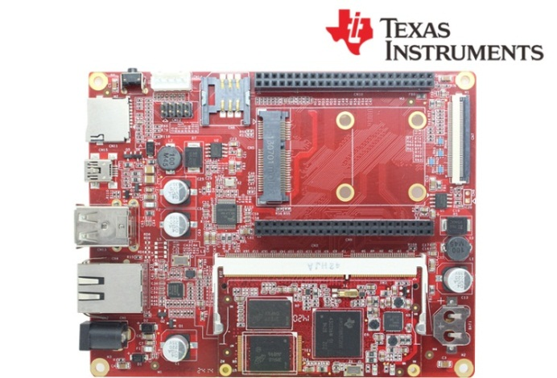](http://www.goembed.com/index.php/Products/detail/tpid/12)

*SBC335x – B2A*

The single board computer SBC335x-B1A/B2A which has an expansion board to carry the CM335X is one of our design of the base plate . The flexible design allows the fast and easy way of realizing and upgrading the controller’s capabilities. In additional to those features offered by CM335X.

The B1A features 4 serial ports (including 2 RS232 and 2 TTL), 4 USB Host and 1 USB OTG, 1 Ethernet ports, CAN, RS485, Wiegand, VGA, LCD, Touch screen, Audio, ADC and more other peripherals.

The B2A features 4 USB Host and 1 USB OTG, 1 Ethernet ports, LCD, Touch screen,RTC, and more other peripherals.

The SBC board targets a wide range of applications, including: HMIs, Digital Signage, POS, Data Terminal, Medical Devices, Navigation, Industrial Automation, Entertainment system, Thin Clients, Robotics, Game Console and much more.

The SBC335x-B1A/B2A are ready-to-run platform to support Linux 3.x, Android 4.x and WinCE 7.0/6.0 operating systems.

If you want to support other Operating System, For more information to contact us.



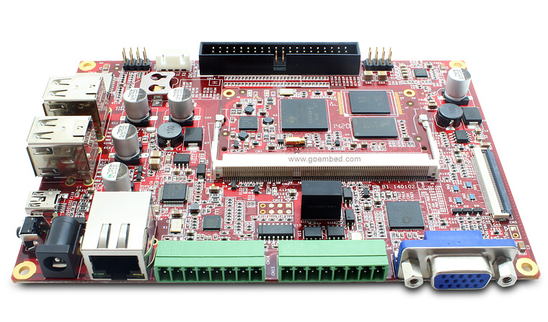

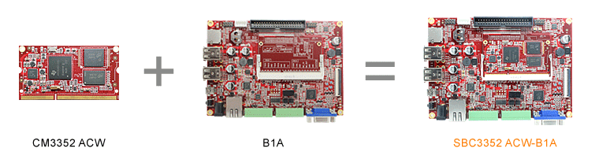

**SBC335x-B1A boards Description of part code:**

|  |  |  |  |  |
| --- | --- | --- | --- | --- |
| **Series** | **B1** | **B1** | **B1** | **B1** |
| **Part Code** | SBC3352 ACW-B1A | SBC3352 BCW-B1A | SBC3358 ACW-B1A | SBC3358 BCW-B1A |
| **Order Code** | - | - | - | - |
| **Core Module** | [CM3352 ACW](http://goembed.com/index.php/Products/detail/tpid/14)  [-M51E20/08](http://goembed.com/index.php/Products/detail/tpid/14) | [CM3352 BCW](http://goembed.com/index.php/Products/detail/tpid/29)  [-M51E40/08](http://goembed.com/index.php/Products/detail/tpid/29) | [CM3358 ACW](http://www.goembed.com/index.php/Products/detail/tpid/44)  [-M51E20/10](http://www.goembed.com/index.php/Products/detail/tpid/44) | [CM3358 BCW](http://goembed.com/index.php/Products/detail/tpid/22)  [-M51E40/10](http://goembed.com/index.php/Products/detail/tpid/22) |
| **CPU Type** | ARM Cortex™-A8 | | | |
| **CPU Cores** | 1x | | | |
| **CPU Clock** | 800MHz | 800MHz | 1.0GHz | 1.0GHz |
| **RAM DDR3** | Micron 512MB@16bit*1 | | | |
| **eMMC Flash** | 2GB@8bit*1 | 4GB@8bit*1 | 2GB@8bit*1 | 4GB@8bit*1 |
| **PMU** | TI TPS65910A3 | | | |
| Supply Voltage | DC 9-14V | | | |
| Optimal Input | DC 12V,1.5A | | | |
| **Size(L*W)** | 146 x 102 mm | | | |
| **Temperature** | 0° to 70° C | | | |
| **Support OS** | Linux 3.x/ Android 4.x/ Ubuntu/ Angstrom/ Debian/ QT/ WinCE 6.0/7.0 | | | |
| **Inventory status** | In Stock | **Out of Stock**  [**Contact us**](mailto:%20sales@goembed.com) | In Stock | **Out of Stock**  [**Contact us**](mailto:%20sales@goembed.com) |
| **Minimum Availability** | 2022 | | | |

**SBC335x-B1A Block Diagram**

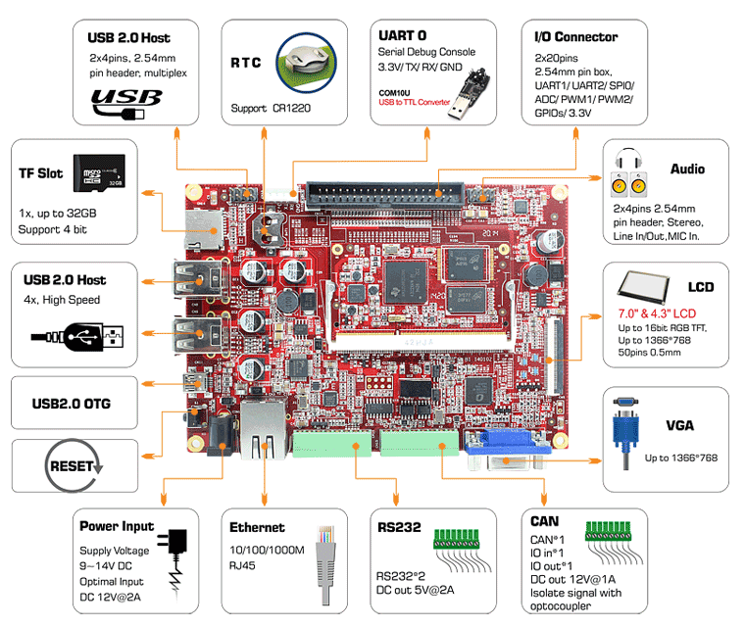

Figure 1 B1 Block Diagram

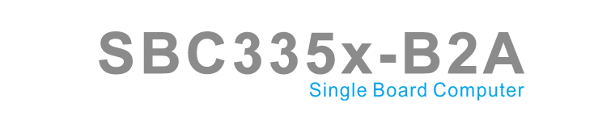

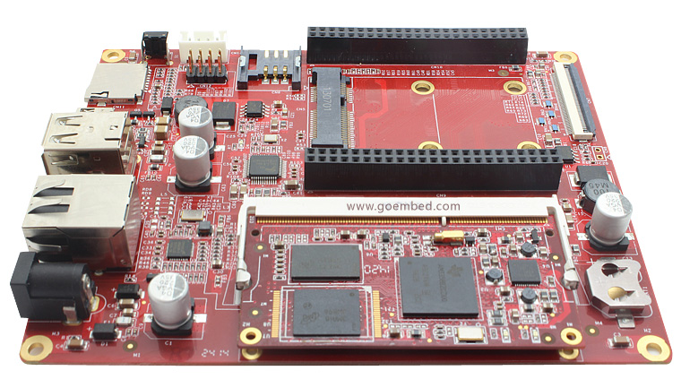

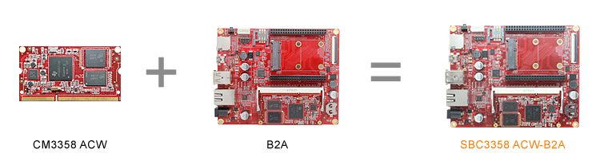

**SBC335x-B2A boards Description of part code:**

|  |  |  |  |  |
| --- | --- | --- | --- | --- |
| **Series** | **B2A** | **B2A** | **B2A** | **B2A** |
| **Part Code** | SBC3352 ACW-B2A | SBC3352 BCW-B2A | SBC3358 ACW-B2A | SBC3358 BCW-B2A |
| **Order Code** | - | - | - | - |
| **Core Module** | [CM3352 ACW](http://goembed.com/index.php/Products/detail/tpid/14)  [-M51E20/08](http://goembed.com/index.php/Products/detail/tpid/14) | [CM3352 BCW](http://goembed.com/index.php/Products/detail/tpid/29)  [-M51E40/08](http://goembed.com/index.php/Products/detail/tpid/29) | [CM3358 ACW](http://www.goembed.com/index.php/Products/detail/tpid/44)  [-M51E20/10](http://www.goembed.com/index.php/Products/detail/tpid/44) | [CM3358 BCW](http://goembed.com/index.php/Products/detail/tpid/22)  [-M51E40/10](http://goembed.com/index.php/Products/detail/tpid/22) |
| **CPU Type** | ARM Cortex™-A8 | | | |
| **CPU Cores** | 1x | | | |
| **CPU Clock** | 800MHz | 800MHz | 1.0GHz | 1.0GHz |
| **RAM DDR3** | Micron 512MB@16bit*1 | | | |
| **eMMC Flash** | 2GB@8bit*1 | 4GB@8bit*1 | 2GB@8bit*1 | 4GB@8bit*1 |
| **PMU** | TI TPS65910A3 | | | |
| Supply Voltage | DC 9-14V | | | |
| Optimal Input | DC 12V,1.5A | | | |
| **Size(L*W)** | 130 x 103.5 mm | | | |
| **Temperature** | 0° to 70° C | | | |
| **Support OS** | Linux 3.x/ Android 4.x/ Ubuntu/ Angstrom/ Debian/ QT/ WinCE 6.0/7.0 | | | |
| **Inventory status** | In Stock | **Out of Stock**  [**Contact us**](mailto:%20sales@goembed.com) | In Stock | **Out of Stock**  [**Contact us**](mailto:%20sales@goembed.com) |
| **Minimum Availability** | 2022 | | | |

**SBC335x-B2A Block Diagram**

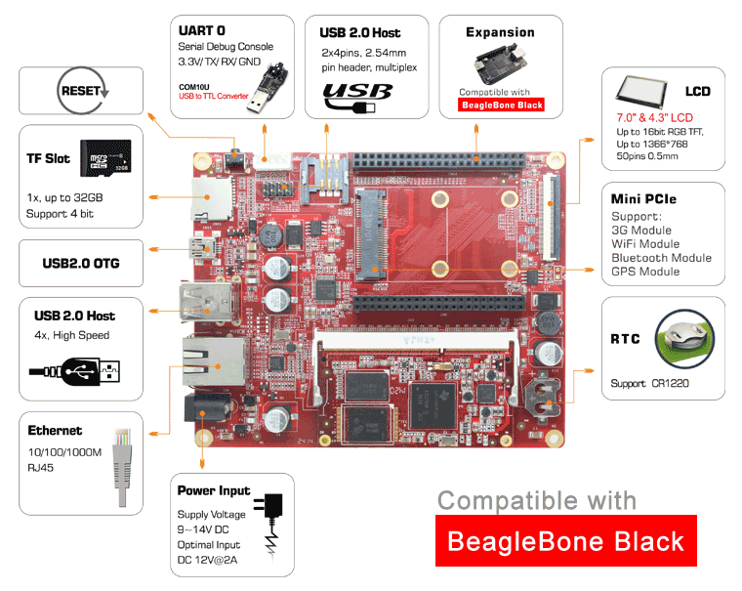

Figure 1 B2A Block Diagram

**ABOUT GOEMBED**

GOEMBED team with experienced embedded engineers who have been engaged in ARM hardware and software design for 10+ years.

Our products include single board computers and CPU core modules based on TI ® Sitara and Freescale ® i.MX Applications Processors based on ARM® Cores. Supported by Linux / Android / Debian / Ubuntu / QT / Angstrom / WinCE 7.0 & 6.0 / uCOS. We can redesign carrier boards and SBC as your idea quickly.

GOEMBED focus on Embedded Board Solutions, provide a complete new board for your specified requirement or even a turnkey solution to accelerate your new products to market.

We are your trust worthy partner on ARM embedded design services and solutions.

**More Carrier Boards**

Customized based on your needs!

**ODM / OEM Services**

Bring your new products to market quickly

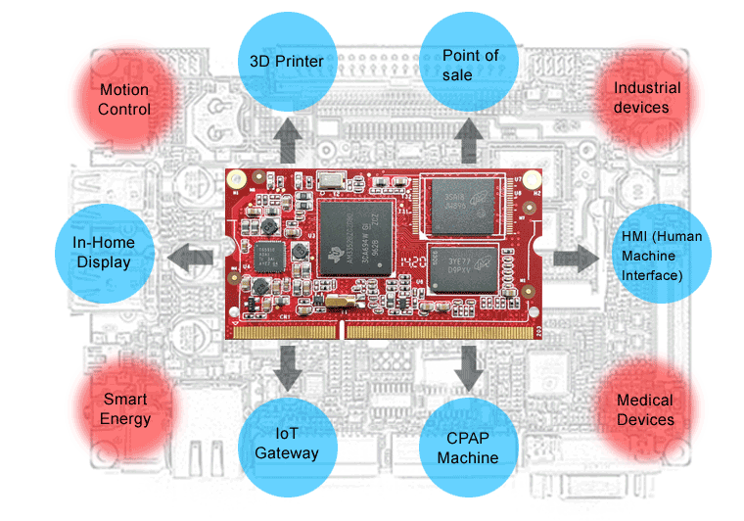

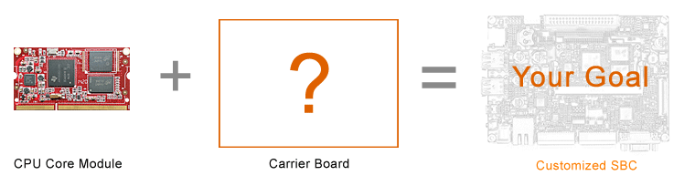

**Related end equipment**

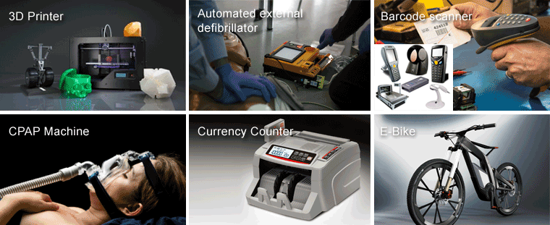

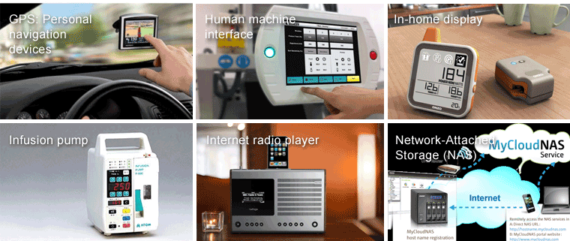

 Learn more applications please click <http://www.ti.com/lsds/ti/apps/appshomepage.page>

